Purpose and Scope:
This procedure describes the experimental setup and method used to estimate the natural convection coefficient, h, for a heated horizontal flat plate inside a thermally insulated enclosure. The test uses one heat flux sensor and two temperature sensors to determine the convective heat flux from the plate and the corresponding temperature difference between the plate surface and the surrounding air. The calculated value of h is then compared with expectations from the flat-plate natural convection model.
The governing equation for the convection coefficient is:
$$\begin{aligned}h = \frac{q_{conv}^{''}}{T_{s}-T_{∞}} \#\left(1\right)\end{aligned}$$

Where $q_{conv}^{''}$ [W/m²] is the total convective heat flux, T_{s} [K] is the surface temperature of the hot plate, and T∞ [K] is the ambient temperature of the box. Because Equation 1 depends only on convective heat flux rather than total heat flux from the plate, a correction must be applied to account for radiation:
$$\begin{aligned}q_{conv}^{''} = q_{measured}^{''}-q_{rad}^{''} \#\left(2\right)\end{aligned}$$

where $q_{measured}^{''}$ [W/m²] is the total measured heat flux from the hot plate as measured by the heat flux sensor and $q_{rad}^{''}$ [W/m²] is the radiative heat flux estimated using Equation 3:

$$\begin{aligned}q_{rad}^{''} = εσT_{s}^{4} \#\left(3\right)\end{aligned}$$

where ε is the material emissivity value of the plates surface and$σ$ is the Stefan-Boltzmann constant ($σ$ = 5.67 x 10⁻⁸ $\frac{W}{m^{2}K}$).

To best estimate h, as the ε value of the hot plate is unknown, it is covered with a single layer of aluminum foil with known low emissivity (ε ≈ 0.03 for aluminum foil with the shiny side facing away from the plate). This enables Equations 2 and 3 to most reliably account for radiative heat flux and therefore improve calculations using Equation 1. Additionally, since the enclosure minimized external airflow over the plate and the plate is only in contact with air, effects of non-natural convection-related conduction and forced convection are negligible.

Lastly, although this procedure is used to estimate the convection coefficient of air, the value of h is dependent on a variety of factors, including hot plate orientation, flow characteristics, surface geometry, and “an assortment of fluid thermodynamic and transport properties” [2]. As such, the measured value of h is specific to this experimental configuration. To assess the validity of the existing model of natural convection, the resulting value should be compared with the tabulated range of h values for air (between 5 and 25 [W/m²K]) or with values reported for similar configurations.
Goals:
- Verify the model of natural convection by estimating the natural convection coefficient of air for a heated horizontal flat plate and comparing with tabulated values
- Program an Arduino Uno to collect two temperature measurements simultaneously and synchronize that data with heat-flux measurements collected using a FluxTeq system.
Equipment Needed:
Note: The following equipment list was adapted from the MEMS 1042 Lab 2 handout [1] and modified to reflect the requirements specific to this procedure.
- Arduino Uno programmable multi-input/output board and USB cable
- Arduino IDE programming software
- Type-K peel-and-stick thermocouple (WATLOW OKK30B10A) with amplifier board (Adafruit MAX31855)
- Platinum RTD sensor (PT100) with amplifier board (Adafruit MAX31865)
- FluxTeq PHFS-01 heat flux sensor, and with it:
  - FluxTeq FluxDAQ Heat Flux Sensor and Thermocouple Measurement System
  - Computer with FluxDAQ program to acquire data
- Breadboard
- 10-15 pin-to-pin jumper wires
- Thermally insulated box (carboard or similar) with removable/openable lid
- Hot plate with adjustable temperature
- Digital Anemometer (Holdpeak HP-866B)
- Duct seal putty
- Aluminum foil
- Duct tape or similar
- Heat-Resistant tape (rated to at least 120 °C)
- Small Phillips head and flat head screwdrivers
- Calibration Equipment:
  - Beaker (or similar) filled with ice bath for calibration
  - Ziploc bags (or similar)
- Heat-resistant gloves
- Fire extinguisher

Procedure:

Sensor Wiring:

Both temperature sensors require signal amplification using two different amplifier boards before the signal is sent through the Arduino to the computer, while the heat flux sensor is connected directly to the FluxDAQ system and doesn’t use Arduino. For the RTD, this is performed using the MAX 31865 amplifier board which converts the RTD’s change in resistance to a voltage before amplification. For the thermocouple, the voltage is measured directly and amplified. An example breadboard with completed wiring for two temperature sensors can be seen in Figure 1. The heat flux sensor (FluxTeq PHFS-01) uses an independent data acquisition system and does not require external signal conditioning.

Note: To avoid any damage to test equipment, ensure the Arduino is disconnected from the computer before adding or adjusting any wiring.
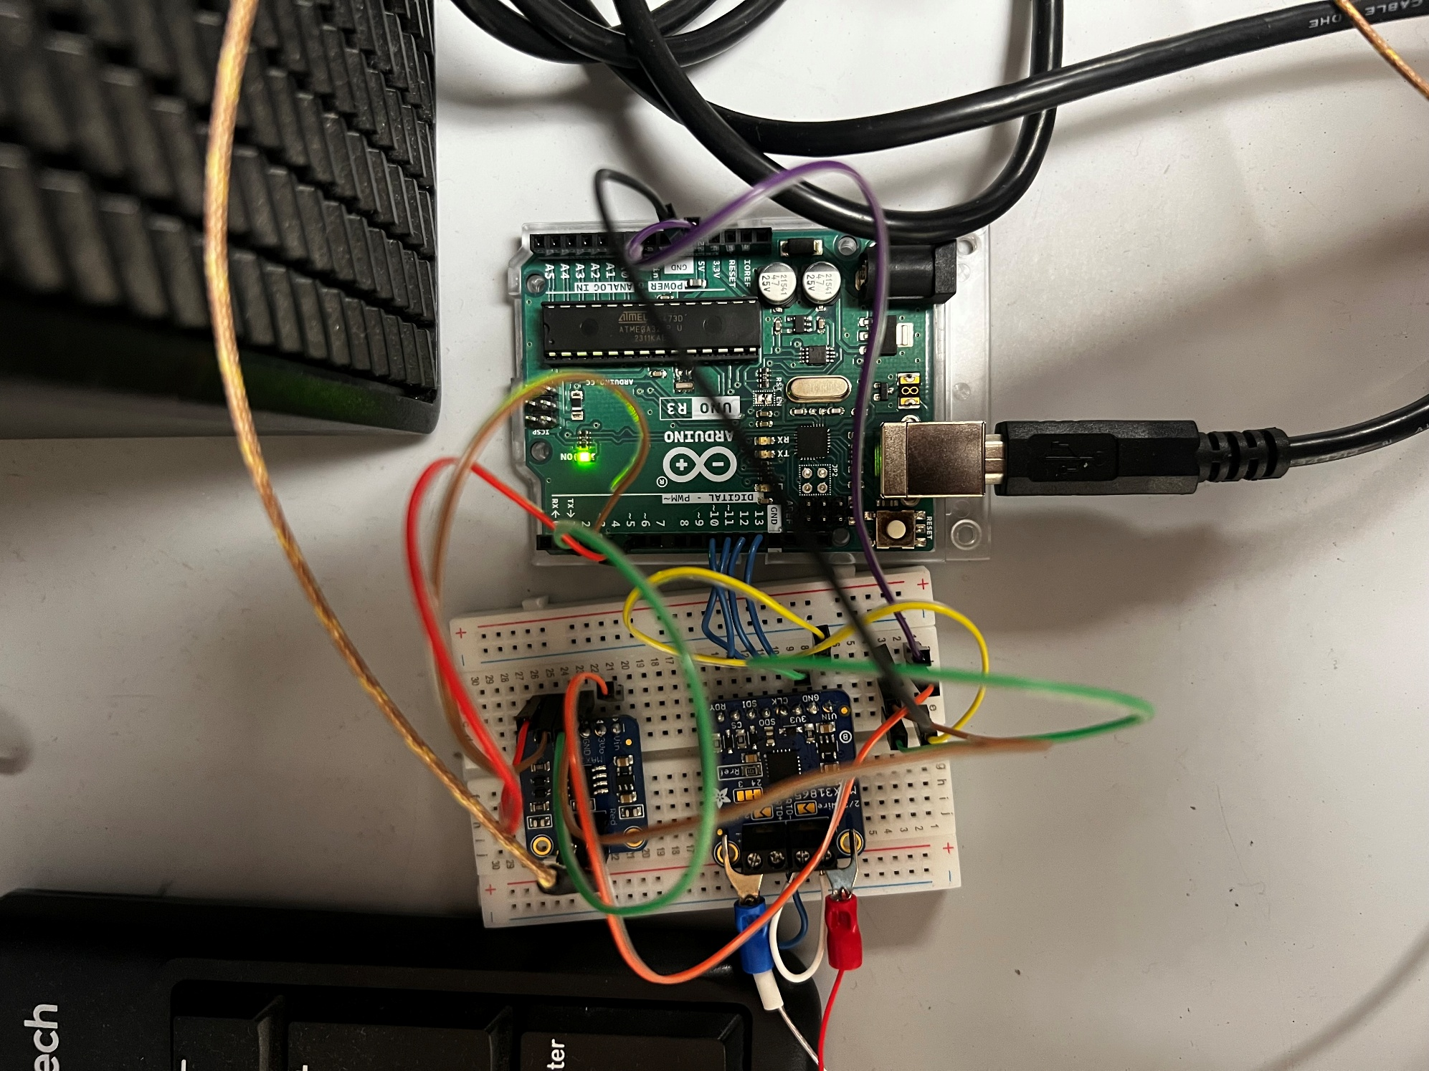
Figure 1: Example of completed temperature sensor and Arduino wiring including both the thermocouple and RTD with their associated amplifiers

RTD Wiring:

The RTD sensor is connected to the Arduino using a MAX31865 amplifier board as shown in Figure 2 below, which converts the resistance change of the RTD into a digital signal via SPI communication.

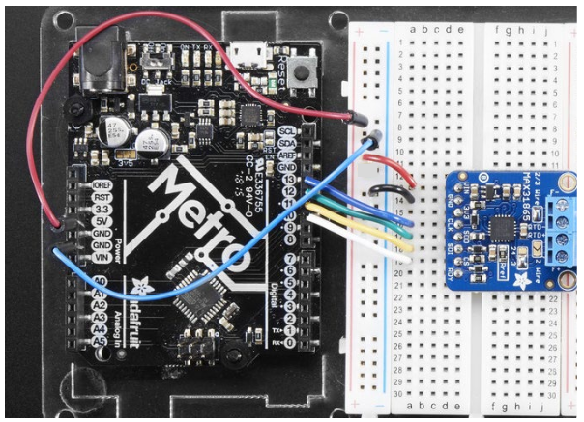

Figure 2: Example of RTD and MAX31865 wiring (https://learn.adafruit.com/adafruit-max31865-rtd-pt100-amplifier/arduino-code)

- Wiring the MAX31865 Amplifier to Arduino:
  - Insert the amplifier board into the breadboard so that each pin is in a separate row.
  - Connect VIN on the amplifier board to the 3.3V pin on the Arduino. (Note: 3.3V is used to reduce electrical noise and improve measurement stability.)
  - Connect GND on the amplifier board to the GND rail on the breadboard.
  - Connect the SPI communication pins between the amplifier and Arduino:
- CLK – Pin 13
- SDO – Pin 12
- SDI – Pin 11
- CS – Pin 10
These connections allow the Arduino to communicate with the amplifier board to read temperature data.
- Connect the RTD to the amplifier:
  - Use a 2-wire configuration as shown in Figure 3 below
  - Insert jumper wires across each terminal pair on the amplifier board
  - Connect one RTD lead to each terminal. (Note: Polarity does not matter since the RTD behaves as a resistor.)
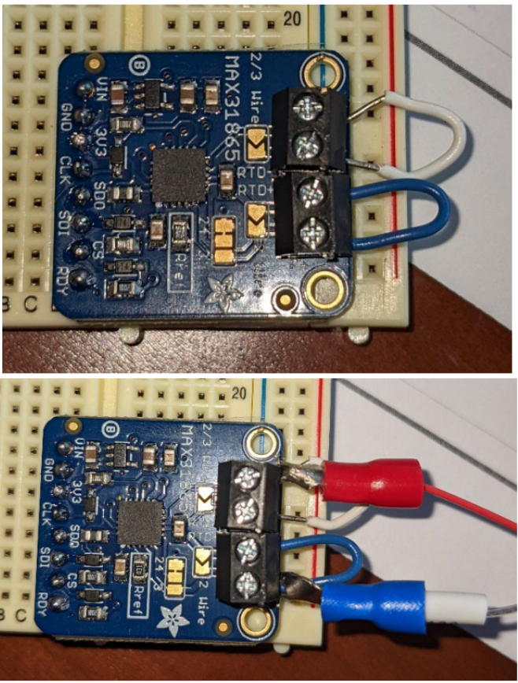
Figure 3: Wiring to connect the RTD to the amplifier board. Top picture shows the jumper wires, bottom picture shows the attached RTD [1]
- Arduino setup and verification
  - Modify the Arduino code to use a 2-wire configuration
  - Upload the program to the Arduino
  - Open the Serial Monitor and verify that temperature readings are approximately equal to the room temperature before calibration.

Thermocouple Wiring:

The thermocouple is connected to the Arduino through a MAX31855 amplifier board, as shown in Figure 4, which measures the small voltage generated by the thermocouple and converts it into a digital signal.
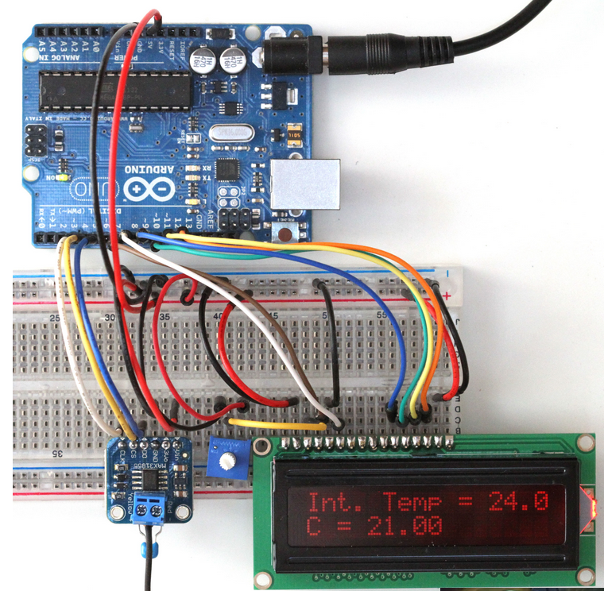
Figure 4: Thermocouple and MAX 31855 Wiring Example with additional LCD display (not used in this procedure) (Figure from https://learn.adafruit.com/thermocouple/arduino-code – this link can also be used for additional wiring information, if needed)

- Connect the thermocouple to the amplifier:
  - Slide the thermocouple leads into terminals as labeled in Figure 5. Connect yellow wire to the (+) terminal and the red wire to the (-) terminal.
  - Secure the leads by tightening the screw using the Phillips head screwdriver.
Note: If in a noisy environment, a 0.1uF capacitor can be added across thermocouple leads.
.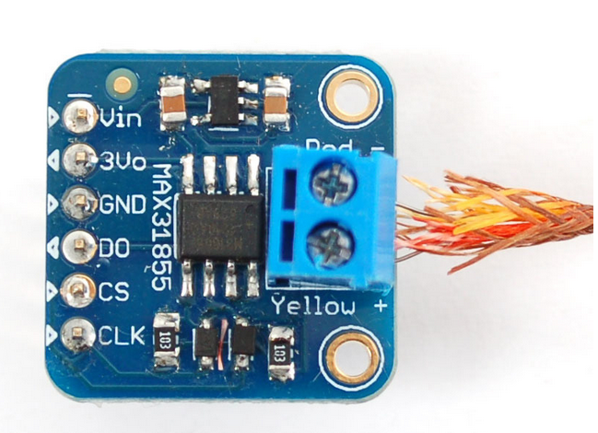
Figure 5: Step 1 – thermocouple lead-to-amplifier connection (https://learn.adafruit.com/thermocouple/arduino-code)

Arduino Setup

- Open Arduino IDE software and copy and paste the provided Arduino code (see Appendix B) into a new sketch before saving.

Note: Ensure all ground and power (voltage input) connections are secured and wired properly before moving on to Step 2 to avoid damaging or destroying the Arduino’s microprocessor chip.

- Connect the Arduino Uno to the computer with the USB cable.
- Select the board and port within the IDE software under the “Tools” menu as shown in Figure 6.
  - Board: “Arduino Uno.”
  - Port: The port refers to the location that the USB cable is plugged into in the computer.
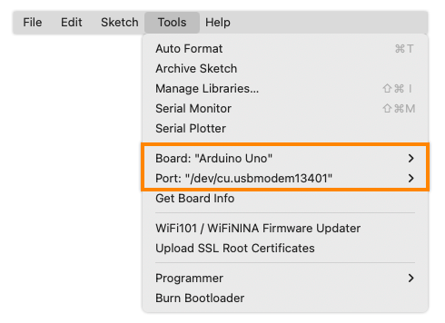
Figure 6: Tools menu in Arduino IDE software (figure from https://support.arduino.cc/hc/en-us/articles/4406856349970-Select-board-and-port-in-Arduino-IDE – see link for additional assistance, if necessary)

- Navigate to the Library Manager tab within the software (see Figure 7), search for Arduino MAX 31855 library and install. Install any required dependencies if prompted.
- Repeat step 4 but install the “Adafruit MAX31865 library” this time.
- Once the libraries are installed, verify the code and upload it to the Arduino Uno (See Figure 7).
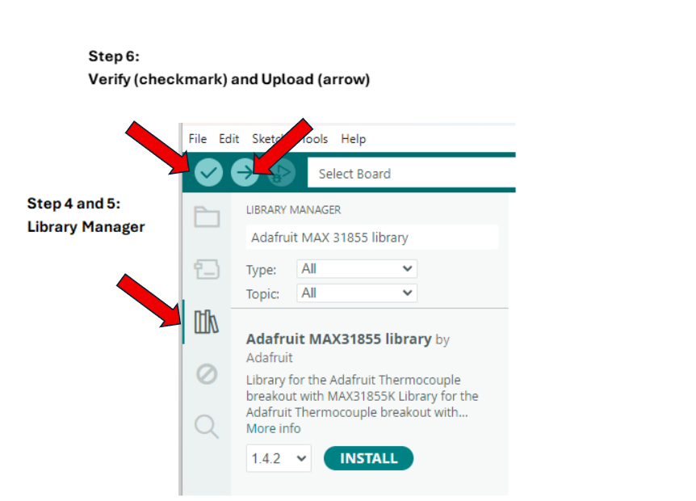Figure 7: Depiction of steps 4-6 in Arduino IDE

- Open the “Serial Monitor” tab and ensure a data collection rate of 115,200 Baud and ensure that “Show timestamp” is toggled on as shown in Figure 8 below.

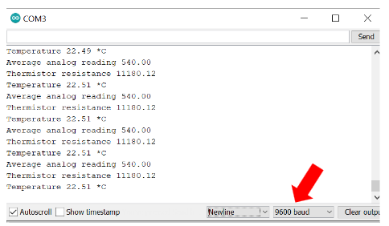
Figure 8: Baud selection (Figure taken and modified from [1]) and “Show timestamp” toggle
- RTD and thermocouple temperature readings (°C) with timestamps should now be displayed in the serial monitor. Verify that temperature readings are approximately equal to the room temperature before calibration.

Troubleshooting: In the event of error messages or a lack of displayed data, first double check breadboard and sensor wiring, ensure there are no short-circuits (a common example occurs with an unwanted metallic object in contact with either amplifier). Double check that the Arduino Setup steps have been completed properly. If the code is displaying error messages within the serial monitor, this may indicate the specific problem as well. Remember to disconnect the Arduino from the computer before adjusting the wiring.

Heat Flux Sensor Wiring

The heat flux sensor (FluxTeq PHFS-01) directly connects to the FluxDAQ data acquisition system. Unlike the temperature sensors, it does not require an Arduino or external amplifier, as signal conditioning and amplification are handled internally by the FluxDAQ system.

- Connect the heat flux sensor to the FluxDAQ:
  - Insert the red lead of the heat flux sensor into the (+) terminal of the selected channel (e.g., CH1), and the white lead into the (-) terminal.
  - Using the small flathead screwdriver ensure that all connections are secure, as shown in figure 9.

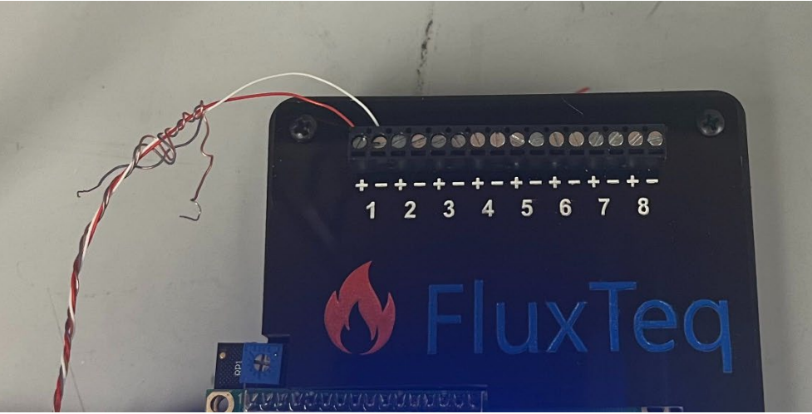
Figure 9: Sample Wiring from Heat Flux Sensor to FluxDAQ [2]
- Connect the FluxDAQ to the computer using a USB cable.
- Configure the sensor in the FluxDAQ software:
  - Set the number of sensors to 1.
  - Enter the sensitivity value corresponding to the sensor’s serial number (see Appendix A) in the first, leftmost “Set Sensor Sensitivities” box and then select set S1 as shown in Figure 10 below.
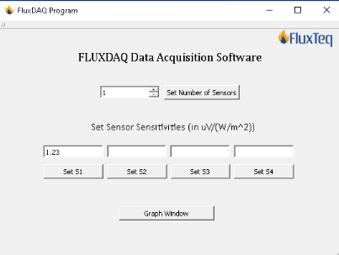
Figure 10: FluxDAQ Program Setup (figure taken from [2])

  - At this point, prior to proceeding with data collection, the flux sensor should first be affixed to the hot plate (see upcoming section: Experimental Setup), and further steps will be described in the section “Running the Test/Data Collection.”

Sensor Calibration:
The temperature sensors are calibrated using an ice bath reference to determine and correct measurement offsets. The heat flux sensor is reported to come pre-calibrated by the manufacturer and should not require recalibration. If recalibration seems necessary, the methods used are described at this webpage, https://www.fluxteq.com/capabilities, however, as this requires significant accuracy and equipment demands, FluxTeq recommends contacting them directly to inquire about their calibration services.

- Fill a beaker with crushed ice and add a small amount of water to create a well-mixed ice bath, ensure the mixture is mostly ice to maintain a temperature of approximately 0°C.
- Place the RTD inside a sealed waterproof barrier such as a Ziploc bag, then insert both temperature sensors into the ice bath, positioning them near the center.
- Allow sensor readings to stabilize for approximately 30-60 seconds, then record the temperature data for about 1 minute.
- Compare measured temperatures to the expected value of 0°C, define the difference as the offset for each sensor.
- Modify the Arduino code to subtract the calculated offset from all temperature readings, verify that corrected values to be about 0°C.
  - Locate the highlighted lines in Figure 11 and adjust the offset_TC and offset_RTD values as needed.
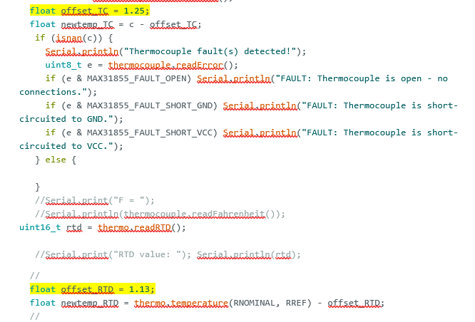Figure 11: Arduino code lines to be updated for calibration
Experimental Setup:
The experimental setup is established to estimate the natural convection coefficient for a heated horizontal flat plate within a thermally insulated enclosure. The setup is optimized to minimize outside airflow and unintended heat transfer, so we can obtain accurate measurements of surface temperature, heat flux, and ambient air temperature to calculate the convection coefficient. An overview of the setup can be seen in Figure 12 below.

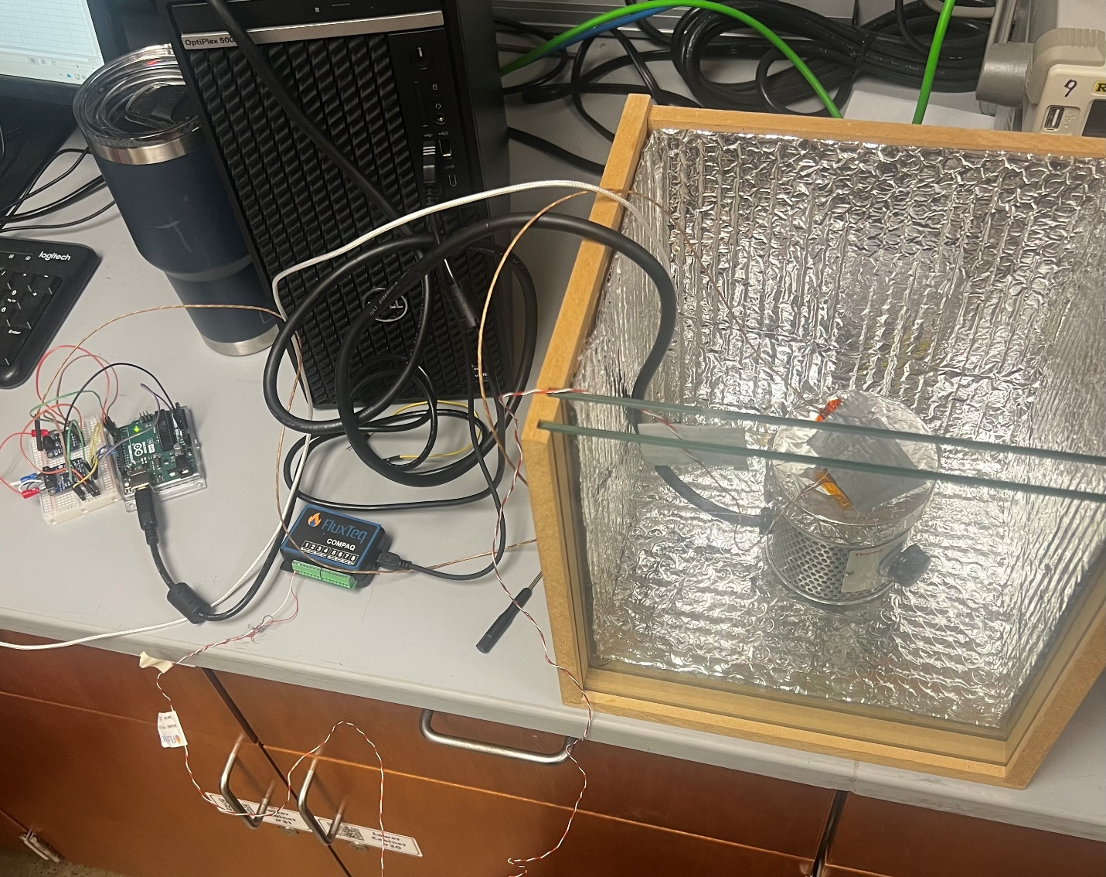
Thermocouple (T_{s} measurement) and heat flux sensor attached to hot plate surface
Platinum RTD (T∞ measurement)
Figure 12: Test setup overview

Physical Setup:
- Insulated enclosure: A box constructed of cardboard and aluminum foil is used to thermally isolate the test region and reduce external airflow (note, the box used in Figure 12 was a premade, custom box made of wood, with two glass panes and internally covered with a thermally insulated material. This is unnecessary for the needs of this experiment). This box has a removable lid that allows access for sensor placement and adjustments. The wire entry points and gaps are sealed with duct seal putty to reduce air leakage. Ensure there is negligible airflow within the enclosure using the digital anemometer (Holdpeak HP-866B).
- Heat source: A hot plate is placed in the middle of the enclosure with the heated surface facing horizontally and upward. This serves as the heated surface for the natural convection experiment.
- Foil covering: The top flat surface of the hot plate is covered with 1 layer of aluminum foil to create a low-emissivity surface and reduce radiation uncertainty. The polished, shiny side of the foil faces upward, away from the plate. For the best results, complete foil-plate contact is desirable with minimal air in between the surfaces.

Sensor Placement:
- Surface temperature measurement: A Watlow OKK30B10A peel-and-stick Type K thermocouple is affixed to the foil covering the hot plate. The purpose is to measure the surface temperature (T_{s}). The position of the thermocouple is also near the heat flux sensor to ensure the two measurements best represent the same area on the surface. See Figure 13 for an example.
- Ambient temperature measurement: A PT100 RTD connected to a MAX31865 amplifier is placed inside the enclosure and suspended to measure the ambient air temperature T∞. The RTD sensor is placed away from the hot plate and the wall of the enclosure to make sure that it can accurately capture the temperature of the surrounding air.
- Heat flux measurement: A FluxTeq PHFS-01 heat flux sensor is mounted on top of the flat-foil-covered hot plate, next to the thermocouple. When mounting the heat flux sensor to the measurement surface, ensure that the side labeled “FluxTeq” faces outward and flat to obtain correct heat flux direction. Secure with heat-resistant tape, as shown in figure 13.
Note: as very low temperatures were being assessed (up to 50 °C) duct tape was able to be used (duct tape adhesive softens at ~60 °C and typically fails around ~90 °C). It is important to be mindful of the heat ratings of the adhesive used and heat-resistant tapes are advised.

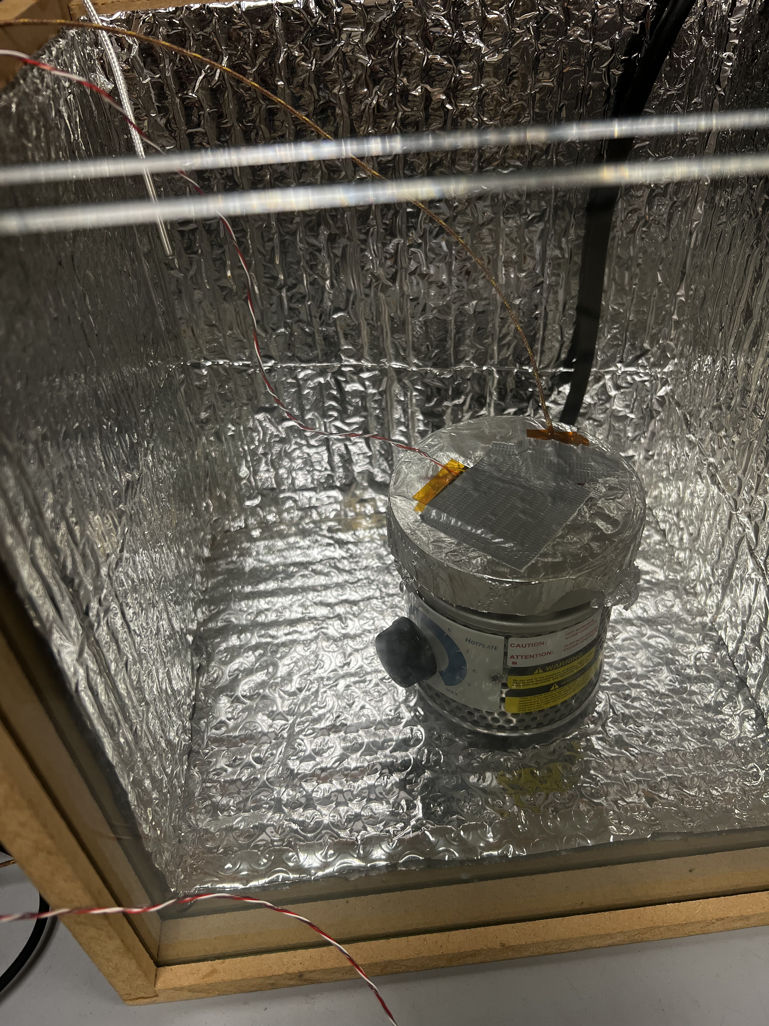
Heat Flux Sensor
Thermocouple (T_{s} measurement)
Figure 13: Heat flux and thermocouple sensor mounting
Running the Test/Data Collection:

With all sensors mounted and calibrated within the enclosure, data collection can begin. Because two independent measurement devices are being used simultaneously, both using different data collection software, the collected data will need to be synchronized (same collection start time) after the collection period.

- Ensure that the temperature sensor data collection code is active and displays up-to-date readouts within the Arduino IDE software Serial Monitor.
- To begin collecting data from the heat flux sensor (at this point the software should be prepared with the sensor sensitivity input (see section: “Heat Flux Sensor Wiring” above if needed) click the “Graph Window” button on the FLUXDAQ Program. A window should be displayed as shown in Figure 14 below. Ensure the “Sensor 1” box is toggled on and press “Start Data.” Heat flux (top plot) and temperature data (bottom plot) should now be collected and displayed graphically within the program. Note: due to the sensor setup, the temperature data collected by flux sensor is incorrect and should be neglected/discarded.

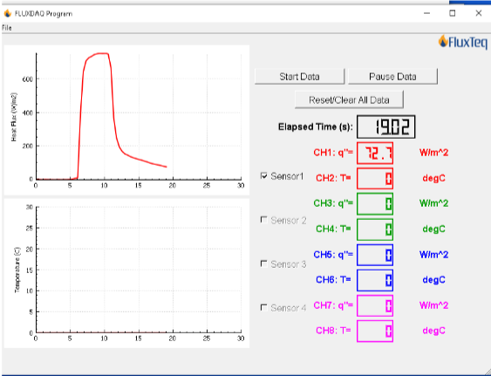
Figure 14: Example FLUXDAQ Program data collection (figure taken from [2])

- Plug in, turn on, and adjust the hot plate to the desired temperature. To avoid damaging the heat flux sensor, this temperature should not exceed 120 °C. Wait until the surface temperature readout within the Serial Monitor stabilizes.
- Once the hot plate surface temperature is stable at the desired value, data collection can begin. Stop heat flux data collection and reset/clear the collected data using the “Pause Data” then “Reset/Clear All Data” buttons respectively.
- To synchronize the data after collection, a shared “start time” is needed. This can be accomplished by determining an upcoming Serial Monitor timestamp which will serve as the start time. Note this time down. It is often easiest to select a time rounded to the nearest second about 20 seconds in the future – e.g. if the Serial Monitor is currently at 12:22:20.726, the time of interest might be 12:22:40.000. Hover the mouse over the “Start Data” button in the FLUXDAQ program and track the displayed timestamps within the Serial Monitor. As exactly as possible, at the first timestamp entry greater than or equal to the time of interest, click the “Start Data” button to begin collecting heat flux data.
  - Although temporally imperfect, because the heat flux is expected to be constant within the enclosure due to the constant T_{s} and T∞ values, imperfect and slightly desynchronized data collection should not pose a significant issue.
- Collect data for approximately one minute before selecting “Pause Data” on the FLUXDAQ Program once the trial is complete. Save the heat flux data as a .csv by clicking “File Save As.” Note the approximate timestamp displayed in the serial monitor at this point.
  - The .csv file can be opened in Excel and contains three columns, in order from left to right, they correspond to Time, Sensor 1 heat flux [W/m²], and Sensor 1 Temperature (which can be discarded).
- Temperature sensor data collection can be accomplished by copying and pasting the Serial Monitor output from the predetermined start time to the stop time to the .csv file in separate columns. It is fine to collect data after the approximate timestamp associated with the trial end, as it can be truncated later.
  - The “Autoscroll” checkbox will need to be toggled off to copy/paste the data
- Using Excel, manipulate the pasted data to form three columns – timestamps and their corresponding RTD and thermocouple temperatures. This can be somewhat tedious, but Excel’s LEFT, RIGHT, and MID functions are helpful to extract specific string from a cell which can be converted from string to a value using the VALUE function.
  - At this point, the .csv file should now contain at a minimum 5 columns:
    - the time and heat flux data columns from the heat flux sensor.
    - timestamps and their corresponding RTD temperatures, and thermocouple temperatures.
- Normalize the time columns around a start time (t = 0 seconds) by subtracting the lowest time/timestamp value from each entry in their corresponding columns. The data should now range from 0 seconds to ~60 seconds.
  - Note, there might be an unequal amount of data entries collected by the temperature sensors and heat flux sensors, this is due to variation in sampling rates. If desired, the temperature sensor code can be adjusted to better reflect the sampling rate of the heat flux sensor.
- Apply the radiation heat flux correction by taking the average surface temperature value during the trial and using this to calculate $q_{rad}^{''}$ via Equation 3. Then subtract this value from the average measured heat flux (Equation 2) to determine $q_{conv}^{''}$. Finally, taking the average of all relevant values (T_{s}, T∞, and $q_{conv}^{''}$) the average convection coefficient across that trial can be determined using Equation 1.

Because each variable within the governing equation for the convection coefficient is expected to remain constant during test trials, test duration would be the simplest variable to increase the reliability of results. However, running multiple tests and comparing the average convection coefficients for each would be another reasonable approach. Additionally, because the data collection is performed using two independent systems, and the sampling rate can be seen to be inconsistent within the Arduino (there is observed variation in sampling period, likely due to computational delays), the user is effectively limited to only characterize the average convection coefficient, however, adjusting the sampling rate within the provided code and interpolating between data samples may be used to compute the approximate convection coefficient for each heat flux sample throughout a test. If maximal accuracy is required, however, a different procedure using one data collection system should be used to avoid errors induced by an imperfect start time estimation and required interpolation. Overall, this procedure is best for determining the average convection coefficient across a trial with constant T_{s} and T∞ values.

Design of Experiments

To systematically investigate the effects of key variables on the natural convection coefficient, a full functional design of experiments (DoE) was developed. This approach allows for the evaluation of individual factor effects and potential interactions between variables.

The factor definitions in Table 1 provide the physical meaning of the coded variables used in DoE. Each factor is assigned to two levels, where –1 represents the low level and +1 represents the high level. This coding simplifies the structure of the design matrix and enables a straightforward comparison of factor effects.

Table 1: Factor Definition
Factor | Description | -1 (Low) | +1 (High)
X1 | T_{s} (Hot Plate Temperature) | 60 °C | 100 °C
X2 | Box Size | Small | Large
X3 | Angle of Hot Plate Surface | 0 ° | 90 °

Table 2 presents the full factorial design matrix for the experiment. Each row represents one experimental run, with a unique combination of factor levels. These 2 levels by factor of 3 design results in eight total runs, ensuring that all possible combinations of the three variables are tested.

Table 2: Design of Experiments Matrix
Run | X1 | X2 | X3
1 | -1 | -1 | -1
2 | +1 | -1 | -1
3 | -1 | +1 | -1
4 | -1 | -1 | +1
5 | +1 | +1 | -1
6 | +1 | -1 | +1
7 | -1 | +1 | +1
8 | +1 | +1 | +1

For each run, the system will be allowed to reach steady-state conditions before measurements are taken. The heat flux and temperature data will be recorded and used to calculate the convection coefficient of each factor can be evaluated.

In addition to identifying the individual effects of temperature, enclosure size, and plate orientation, this design also allows for the observation of potential interaction effects between variables. To improve experimental reliability, multiple measurements may be taken at each condition and averaged.

Safety Considerations:

As this procedure requires the use of a hot plate at up to 120 °C, safety practices must be considered to avoid injury or accidents.
- Ensure the box/enclosure is placed securely and completely on a stable workspace, be conscious to not disrupt or potentially knock down the box during experimentation.
- Use caution and remain attentive during trials until the hot plate has cooled to at least 40 °C.
- If the flux sensor or thermocouple must be adjusted, turn off the hot plate and ensure it has cooled to room temperature before adjusting. If adjustment during the test is necessary, have heat-resistant gloves or similar on hand.
- Only use sensors and adhesives within their proper operating ranges.
- Remain patient when heating the hot plate, progressively and slowly increase the surface temperature to avoid heating beyond desired and safe temperatures.
- Because hot plates can reach extremely high temperatures, improper usage can be a fire hazard. Therefore, a fire extinguisher should always be readily available during testing.

Test Shutdown

Turn off the hot plate and let it cool until it reaches room temperature. Close the FluxDaq program as well as the Arduino data collection script, while making sure to save your FluxDaq csv, and save the Arduino data to a file format of your choice (Excel is recommended.) Disconnect the power supply from the Arduino. After waiting for the hot plate to cool, or by using heat-resistant gloves, remove the tinfoil from the hot plate and carefully remove the thermocouple and heat flux sensor from the tinfoil before disposing of the tinfoil. Disassemble the breadboard circuit. Lastly, place all equipment inside their original containers and return to corresponding storage locations.

Appendices:
Appendix A – FluxTeq Sensitivities for FluxTeq PHFS-01e Heat Flux Sensors:
Table 3: FluxTeq PHFS-01e Heat Flux Sensor sensitivities organized by serial number (taken from [4])
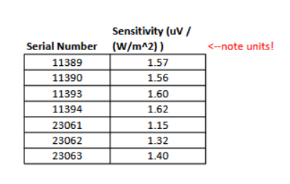

Appendix B – Arduino Code for Temperature Data collection:

Note: the following code is a modified, combined version of sample codes provided in the Arduino MAX31855 and MAX31865 libraries [5-6].

#include <Adafruit_MAX31855.h>

/***************************************************
This is an example for the Adafruit Thermocouple Sensor w/MAX31855K

Designed specifically to work with the Adafruit Thermocouple Sensor
----> https://www.adafruit.com/products/269

These displays use SPI to communicate, 3 pins are required to
interface
Adafruit invests time and resources providing this open source code,
please support Adafruit and open-source hardware by purchasing
products from Adafruit!

Written by Limor Fried/Ladyada for Adafruit Industries.
BSD license, all text above must be included in any redistribution
****************************************************/

#include <SPI.h>
#include "Adafruit_MAX31855.h"
#include <Adafruit_MAX31865.h>
#include <Adafruit_MAX31865.h>

// Default connection is using software SPI, but comment and uncomment one of
// the two examples below to switch between software SPI and hardware SPI:

// Use software SPI: CS, DI, DO, CLK
Adafruit_MAX31865 thermo = Adafruit_MAX31865(10, 11, 12, 13);
// use hardware SPI, just pass in the CS pin
//Adafruit_MAX31865 thermo = Adafruit_MAX31865(10);

// The value of the Rref resistor. Use 430.0 for PT100 and 4300.0 for PT1000
#define RREF 430.0
// The 'nominal' 0-degrees-C resistance of the sensor
// 100.0 for PT100, 1000.0 for PT1000
#define RNOMINAL 100.0

// Example creating a thermocouple instance with software SPI on any three
// digital IO pins.
#define MAXDO 3
#define MAXCS 4
#define MAXCLK 5

// initialize the Thermocouple
Adafruit_MAX31855 thermocouple(MAXCLK, MAXCS, MAXDO);

// Example creating a thermocouple instance with hardware SPI
// on a given CS pin.
//#define MAXCS 10
//Adafruit_MAX31855 thermocouple(MAXCS);

// Example creating a thermocouple instance with hardware SPI
// on SPI1 using specified CS pin.
//#define MAXCS 10
//Adafruit_MAX31855 thermocouple(MAXCS, SPI1);

void setup() {
Serial.begin(115200);
Serial.println("Adafruit MAX31865 PT100 Sensor Test!");

thermo.begin(MAX31865_2WIRE); // set to 2WIRE or 4WIRE as necessary
while (!Serial) delay(1); // wait for Serial on Leonardo/Zero, etc

Serial.println("MAX31855 test");
// wait for MAX chip to stabilize
delay(500);
Serial.print("Initializing sensor...");
if (!thermocouple.begin()) {
Serial.println("ERROR.");
while (1) delay(10);
}

// OPTIONAL: Can configure fault checks as desired (default is ALL)
// Multiple checks can be logically OR'd together.
// thermocouple.setFaultChecks(MAX31855_FAULT_OPEN | MAX31855_FAULT_SHORT_VCC); // short to GND fault is ignored

Serial.println("DONE.");
}

void loop() {
// basic readout test, just print the current temp
//Serial.print("ThCouple Internal Temp = ");
//Serial.println(thermocouple.readInternal());

double c = thermocouple.readCelsius();
float offset_TC = 1.25;
float newtemp_TC = c - offset_TC;
if (isnan(c)) {
Serial.println("Thermocouple fault(s) detected!");
uint8_t e = thermocouple.readError();
if (e & MAX31855_FAULT_OPEN) Serial.println("FAULT: Thermocouple is open - no connections.");
if (e & MAX31855_FAULT_SHORT_GND) Serial.println("FAULT: Thermocouple is short-circuited to GND.");
if (e & MAX31855_FAULT_SHORT_VCC) Serial.println("FAULT: Thermocouple is short-circuited to VCC.");
} else {

}
//Serial.print("F = ");
//Serial.println(thermocouple.readFahrenheit());
uint16_t rtd = thermo.readRTD();

//Serial.print("RTD value: "); Serial.println(rtd);
//
float offset_RTD = 1.13;
float newtemp_RTD = thermo.temperature(RNOMINAL, RREF) - offset_RTD;
//
float ratio = rtd;
ratio /= 32768;
//Serial.print("Ratio = "); Serial.println(ratio,8);
//Serial.print("Resistance = "); Serial.println(RREF*ratio,8);
Serial.print("RTD C = "); Serial.print(newtemp_RTD); Serial.print("; ");

Serial.print("ThCouple C = "); Serial.println(newtemp_TC);

//Serial.println(c);
//

// Check and print any faults
uint8_t fault = thermo.readFault();
if (fault) {
Serial.print("Fault 0x"); Serial.println(fault, HEX);
if (fault & MAX31865_FAULT_HIGHTHRESH) {
Serial.println("RTD High Threshold");
}
if (fault & MAX31865_FAULT_LOWTHRESH) {
Serial.println("RTD Low Threshold");
}
if (fault & MAX31865_FAULT_REFINLOW) {
Serial.println("REFIN- > 0.85 x Bias");
}
if (fault & MAX31865_FAULT_REFINHIGH) {
Serial.println("REFIN- < 0.85 x Bias - FORCE- open");
}
if (fault & MAX31865_FAULT_RTDINLOW) {
Serial.println("RTDIN- < 0.85 x Bias - FORCE- open");
}
if (fault & MAX31865_FAULT_OVUV) {
Serial.println("Under/Over voltage");
}
thermo.clearFault();
}
//Serial.println();
delay(1000);
}

/***************************************************
This is a library for the Adafruit PT100/P1000 RTD Sensor w/MAX31865

Designed specifically to work with the Adafruit RTD Sensor
----> https://www.adafruit.com/products/3328

This sensor uses SPI to communicate, 4 pins are required to
interface
Adafruit invests time and resources providing this open source code,
please support Adafruit and open-source hardware by purchasing
products from Adafruit!

Written by Limor Fried/Ladyada for Adafruit Industries.
BSD license, all text above must be included in any redistribution
****************************************************/

References:
[1] Vipperman, J., “Lab 1 Handout - Sensor Selection and Calibration for Arduino”, University of Pittsburgh, 2026.
[2] Vipperman, J., “Lab 2 Handout - Insulation R-Value of Single-Pane and Dual-Pane Windows”, University of Pittsburgh, 2026.
[3] Bergman, Lavine, Incropera, and Dewitt, “Fundamentals of Heat and Mass Transfer”, 7th Edition, John Wiley and Sons, 2011
[4] Vipperman, J., “sensitivities.xlsx”, University of Pittsburgh, 2026.
[5] Arduino, "Adafruit MAX 31855 library," Arduino Documentation, Nov., 15, 2023​
[6] Arduino, "Adafruit MAX 31865 library," Arduino Documentation, Nov., 15, 2023

